Year 12 Software Development

SAT : Criteria 5

DESIGN FOLIO

For

ItemIQ

By

Thomas Andrews

1: Provide 2-3 Alternative Design Ideas

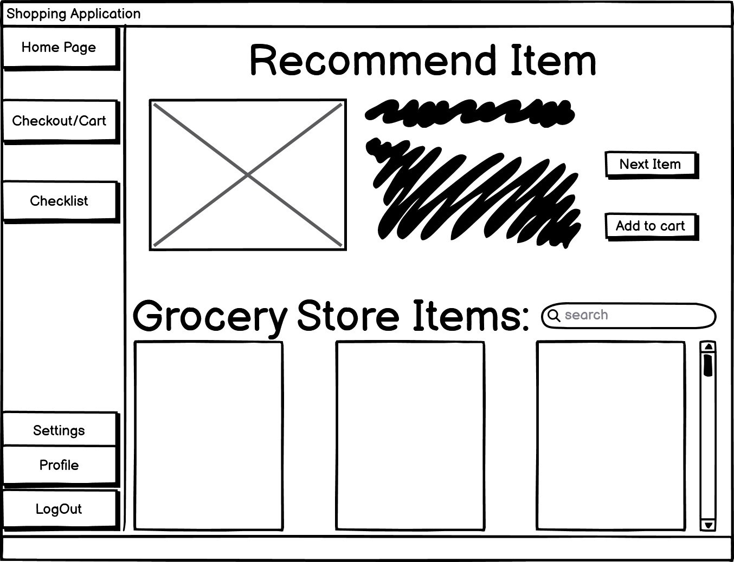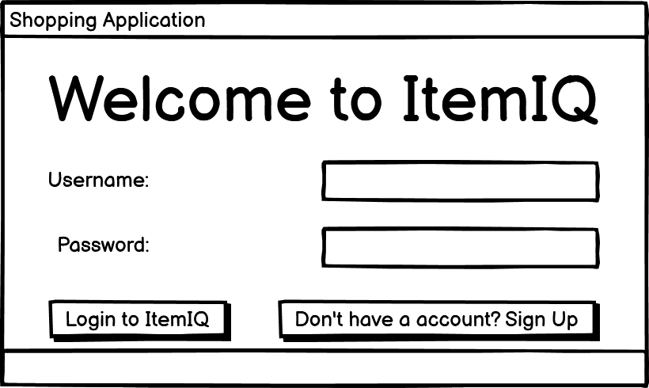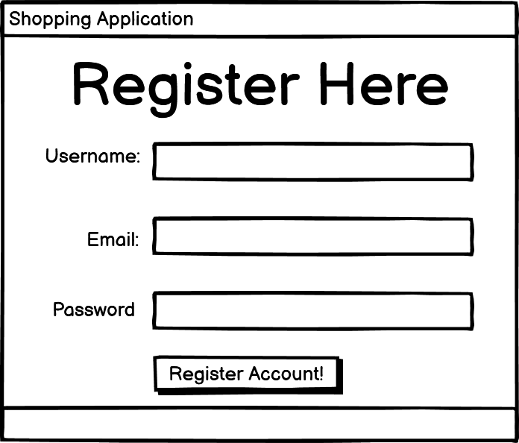Design 1: Mockup

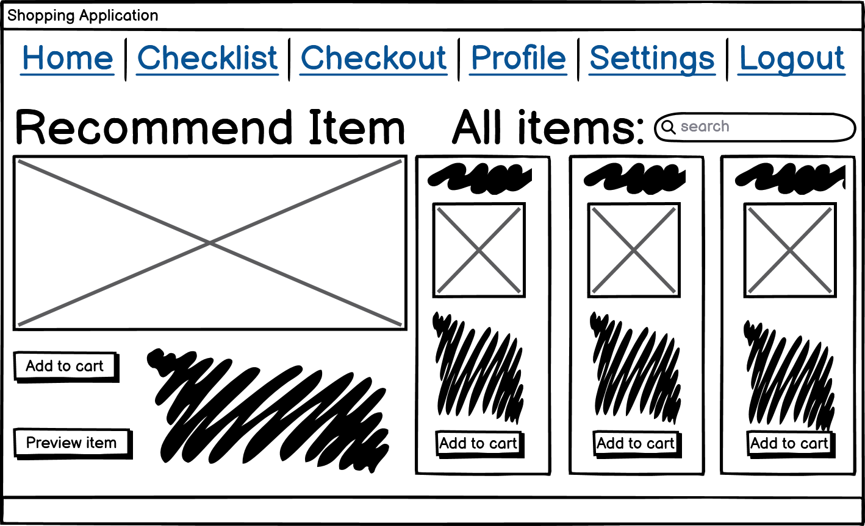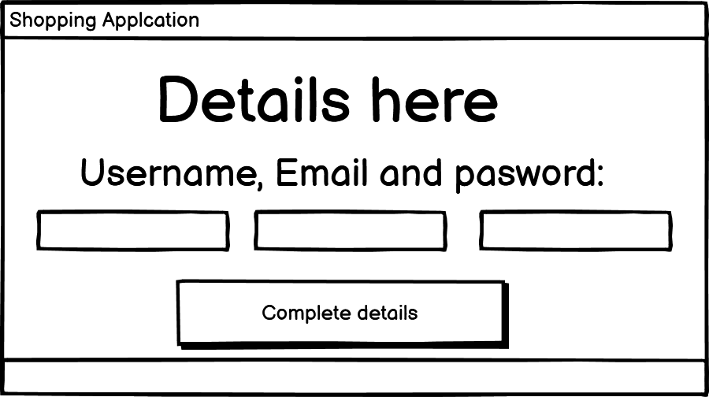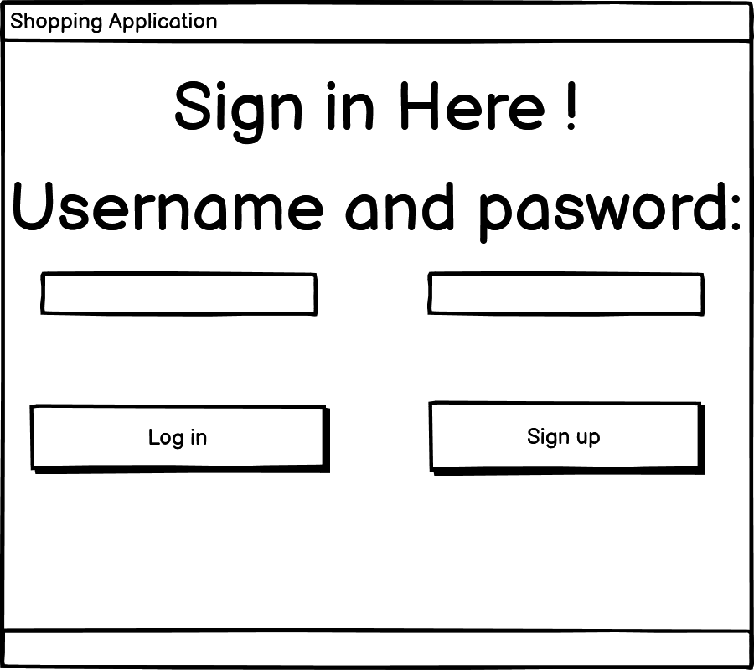Design 2: Mockup

2. Evaluation Criteria for designs

Evaluation Criteria:

|  |  |
| --- | --- |
| Criterion 1 | Easy to navigate around the site |
| Criterion 2 | UI friendly |
| Criterion 3 | Crash safe site (reliability on the server with no bugs) |
| Criterion 4 | Functionality (Helps users buy items from the store) |
| Criterion 5 | Time efficiency with loading tasks/different pages |
| Criterion 6 | Accuracy of data recommend to you |
| Criterion 7 | Relevance |
| Criterion 8 | Attractiveness |

Preferred Design: Design 1 is my preferred

3. Justification of Preferred Design

I picked design number one because the design satisfied the needs of the evaluation criteria as the site functions with speed between pages and button with no errors or crashes. The is site is easy to navigate as all the different pages/scenes can opened through the nav bar on the left all labelled with proper naming conventions. As the site is easy navigate with the nav bar and has big fonts to grab attention to important things this checks off the UI friendly and attractiveness evaluation it also completes all the functional requirements which checks off functionality evaluation. As design 1 checks off all of the evaluation criteria table, Which makes it my choice for the development stage as it would satisfy a clients needs and mine, With the development stage should be easier and quicker to develop and plan for the rest of the project.

4. Detailed Design

:

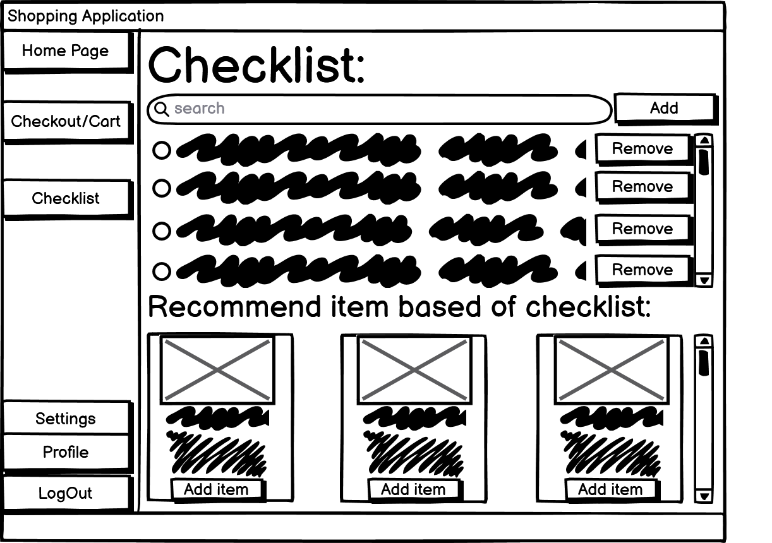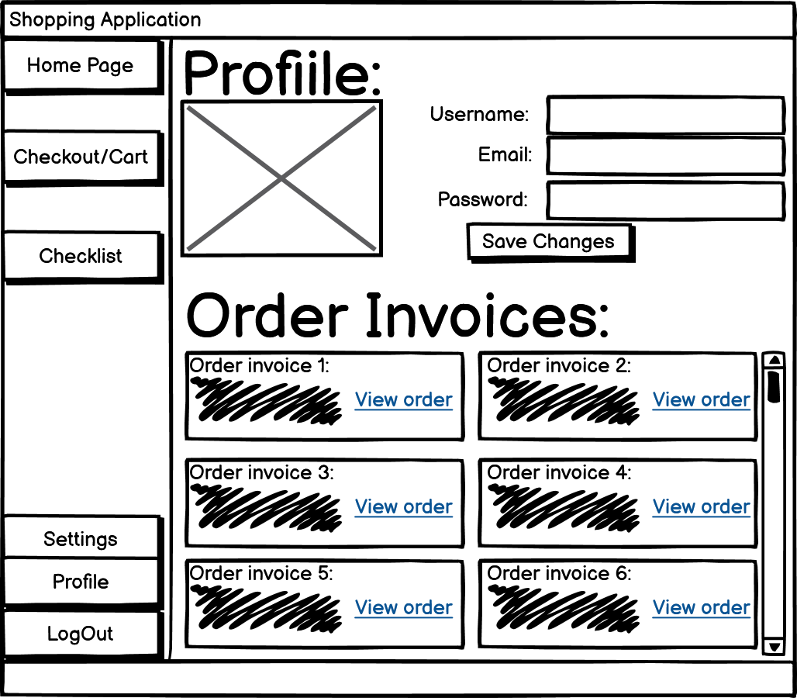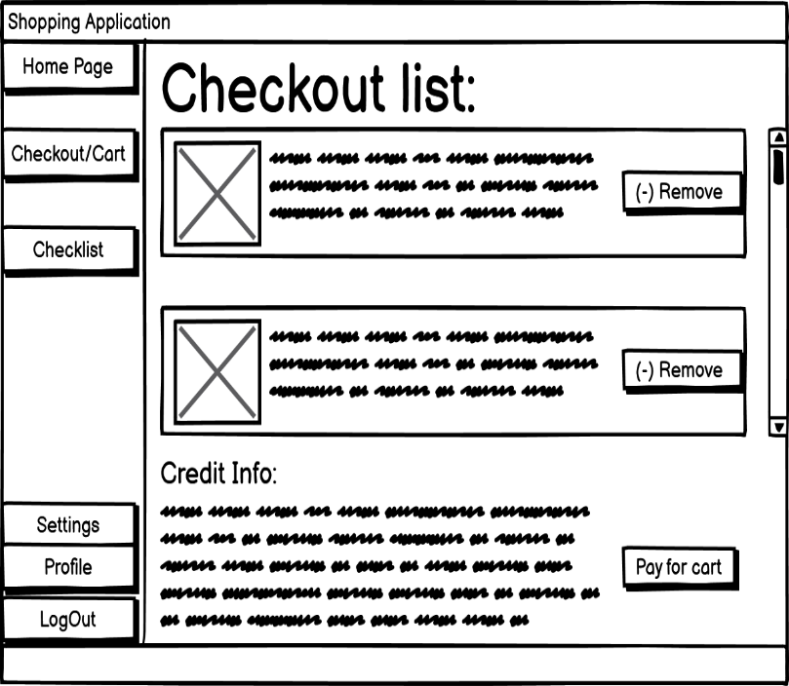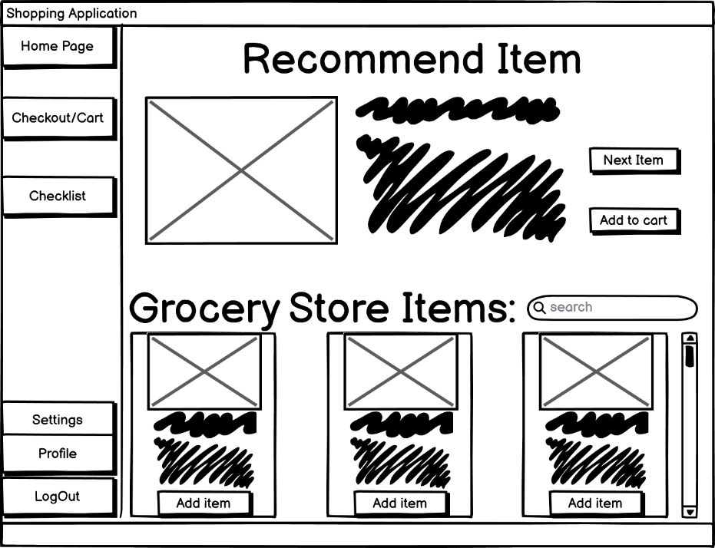

Data Dictionary

|  |  |  |  |
| --- | --- | --- | --- |
| Name | Type | Format/Size | Purpose |
| Username | String | & *20 | A variable assigned to the user to represented its account |
| Email | String | & *20 @gmail.com | A variable assigned to the user to get info and updates on the site to their gmail |
| Password | String | & *20 | A variable to allow access into the site when entering this variable correctly |
| First_name | String | & *20 | First name of the user which helps identify them |
| Last_name | String | & *20 | Last name of the user which helps identify them |
| Credit_Number | Integer | & *16 | This is the number on your card to pay for payments in checkout which will get assigned to a varaible |
| CreditCard_Date | Integer | &&/&& | This the date on your card to play for cart payment for your order |
| CreditCard_Cvc | Integer | &&& or &&&& | The number on the back of your card to verify its your card for the payment of your order |

Pseudocode

**Pseudocode to login to your account with correct account details**

BEGIN

OPEN PersonalDataArray

Username ← Username.txt;

Email ← Email.txt;

Password ← Password.txt

LoginDetails ← false

FOR IndividualDataArray() ← 1 to last in PersonalDataArray

IF (IndividualDataArray(?).Name = Username)

If (RecordedDataArray(1) == Email && RecordedDataArray(2) == Password)

LoginDetails ← true;

ENDIF

ENDIF

NEXT

CLOSE PersonalDataArray

IF LoginDetails = TRUE THEN

Open HomePage.Form

ELSE

PRINT “Incorrect Details”

END IF

END

**Pseudocode to change your Username/Email/Password to your profile**

BEGIN

OPEN PersonalDataArray

CurrentUsername <- Username.txt

CurrentEmail <- Email.txt

CurrentPassword <- Password.txt

FOR IndividualDataArray() ← 1 to last in PersonalDataArray

IF ( IndividualDataArray(?).Name = CurrentUsername) THEN

IndividualDataArray(0) <- ChangedUsername.txt

IndividualDataArray(1) <- ChangedEmail.txt

IndividualDataArray(2) <- ChangedPassword.txt

END If

CLOSE PersonalDataArray

END

Object Descriptions

|  |  |  |
| --- | --- | --- |
| Name | Type | Description |
| BtnLogin | Event: Click | When the button is click, it will start a searching algorithm that will check your details with the data on record to see if you are allowed to access the site |
| BtnRegisterForm | Event: Click | When the button is clicked, It will send you to the register form where you can put your details in to make a account to access the site |
| RegisterForm | Event: load | When you click the button RegisterForm it will called this event/method which will open and load the register form page |
| BtnRegister | Event: click | When you details are entered into the input boxes and you click the button it will send you back to the login page |
| LoginForm | Event: load | When you click the button Register or logout button, it will call this event/method to open and load the login page |
| HomeForm | Event: Load | When you click the button login or the homepage button which is on every page except login and register, it will call the event/method to open and load the home with all the dynamic data using API’s |
| BtnNextItem | Event: click | When you click this button, it will load the next recommended item on the list recommendations by calling event/method that will use api or data storage for the next item |
| BtnAdd | Event: click | When you click this button, it will call an event/method to add the item related to the add button which adds it to checkout for later |
| BtnCheckout | Event: click | When you click this button, it will call an event/method to load the checkout page which will presented items that are added to cart through Btnadd which will show what your paying for |
| Checkout Page | Event: load | When you click the btncheckout button it will load this event/method |
| BtnChecklist | Event: click | When you click this button, it will call an event/method to load the checklist page which will show a page where you can make a checklist for items to buy and recommend items based off the list |
| BtnSettings | Event: click | When you click this button, it will call an event/method to load the settings page to show adjustments you can make to your profile and page to make it look different or act different |
| BtnProfile | Event: click | When you click this button, it will call an event/method to load your profile page which will show your current username/email/password and all your past order invoices |
| BtnLogout | Event: click | When you click this button, it will call an event/method to log out of the site and your account where you will have to relog in to access the site again |